KUBERNETES TASK 01

Setup Minikube in your local machine.

Install minikube on windows:
Step 1 : - Install Docker on windows.
https://desktop.docker.com/win/main/amd64/Docker%20Desktop%20Installer.exe?utm_source=docker&utm_medium=webreferral&utm_campaign=docs-driven-download-win-amd64&_gl=1*1xmpvt4*_gcl_au*MTcxMDY2MjExMy4xNzY0MDAyNzM2*_ga*MTU0MzE2OTg3Mi4xNzYzOTg4OTEw*_ga_XJWPQMJYHQ*czE3NjU4ODczNjkkbzIwJGcxJHQxNzY1ODg3MzcxJGo1OCRsMCRoMA..
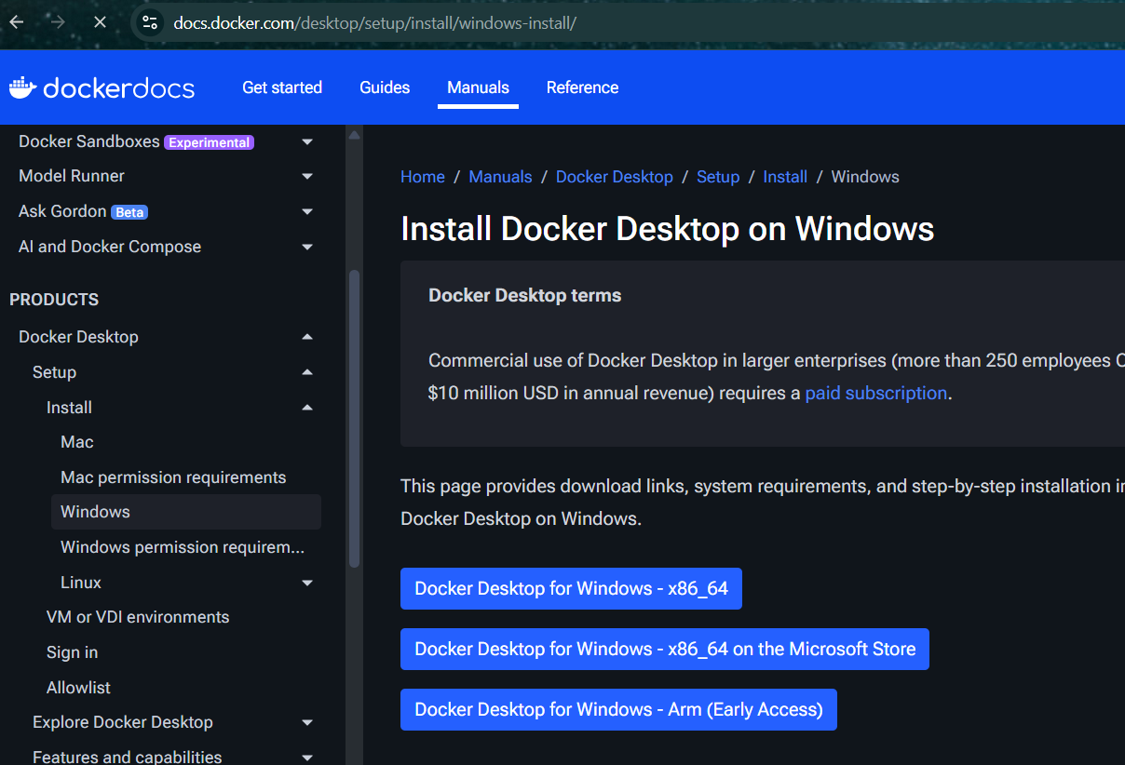
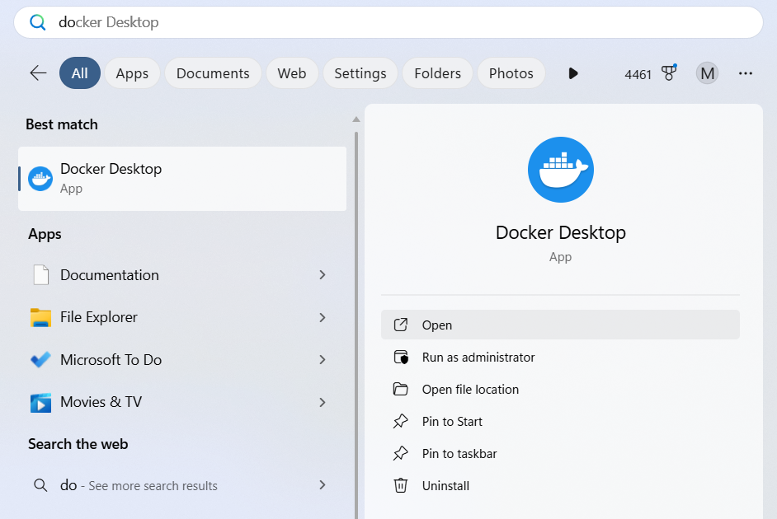
  - Step 2 :- Install Oracle box on windows
  - https://www.virtualbox.org/wiki/Downloads
select your type of machine to download
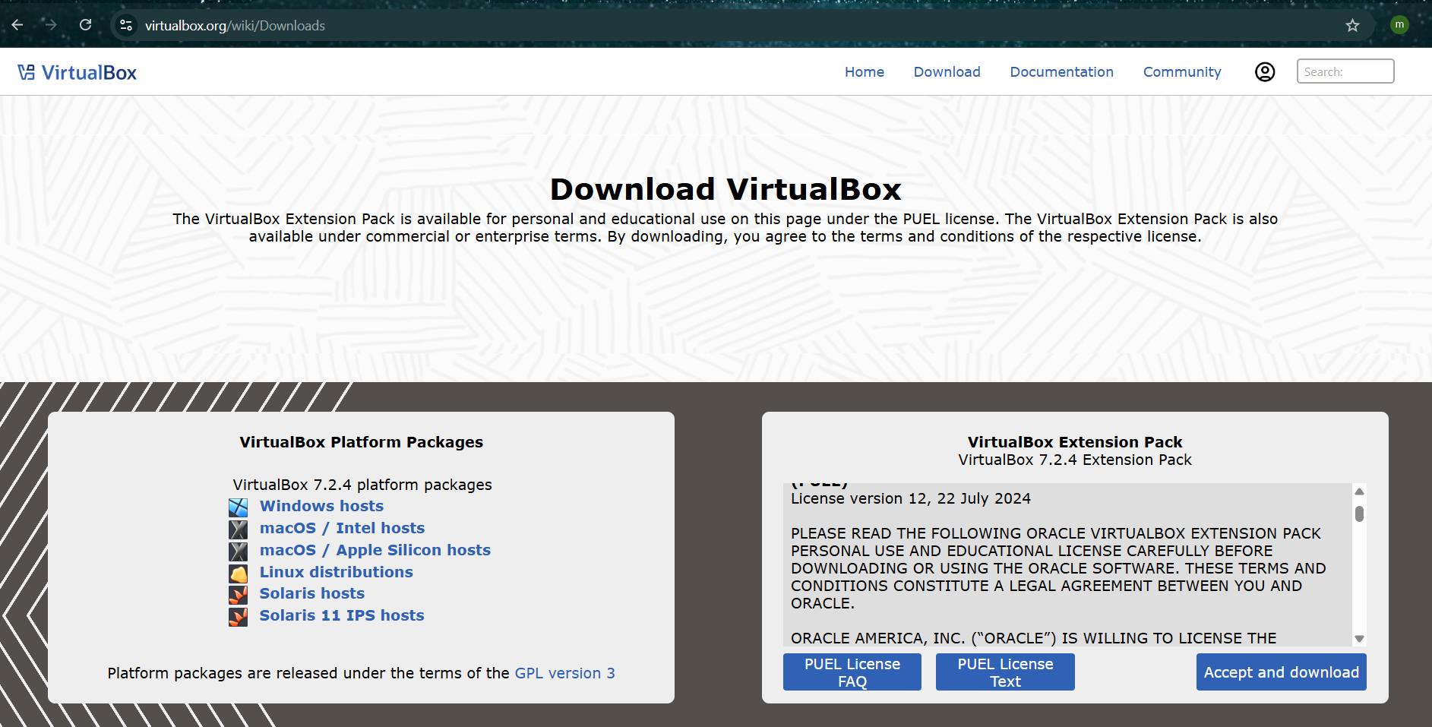

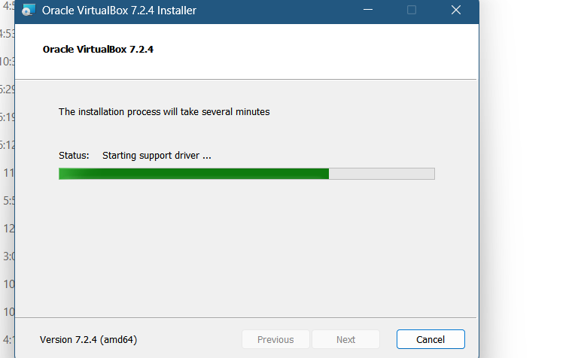
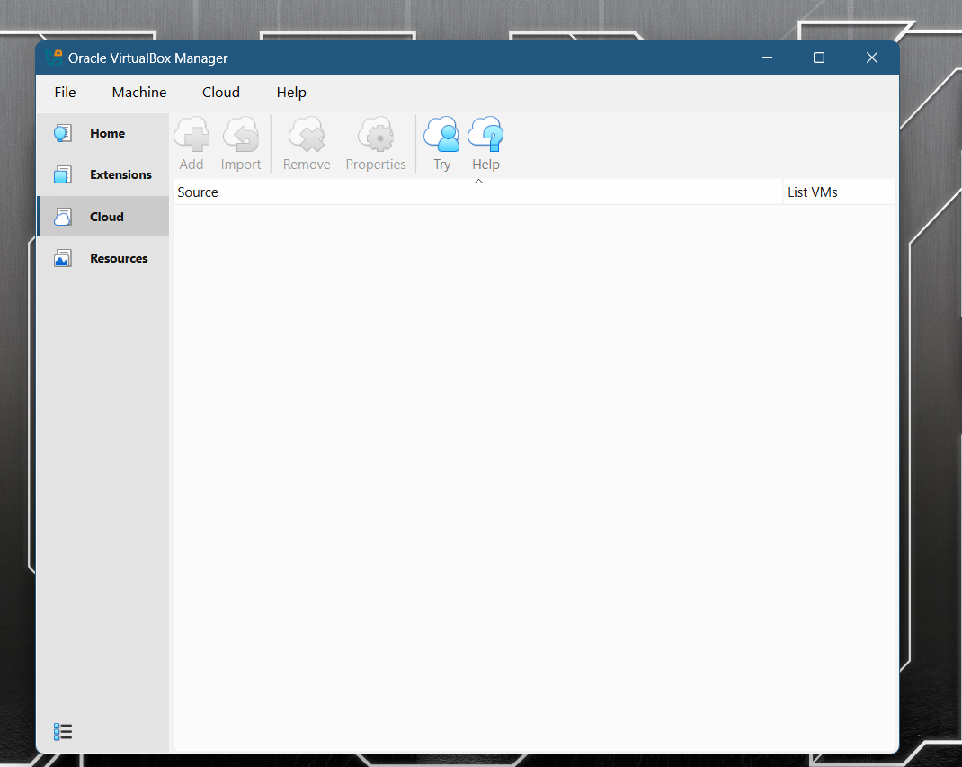

Check systeminfo in powershell
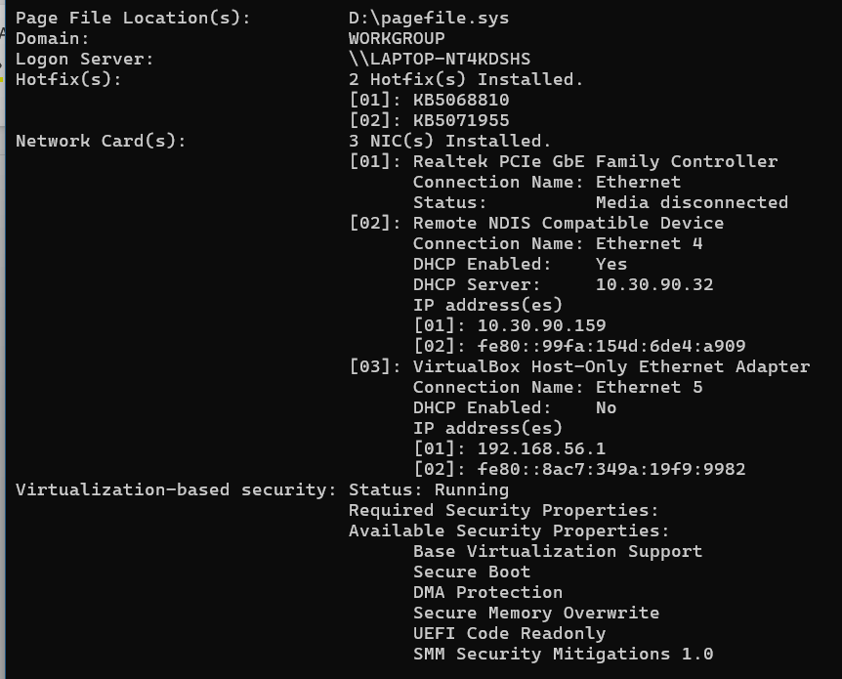
  - Step 3 : Install Minikube using powershell
  - https://minikube.sigs.k8s.io/docs/start/?arch=%2Fwindows%2Fx86-64%2Fstable%2F.exe+download
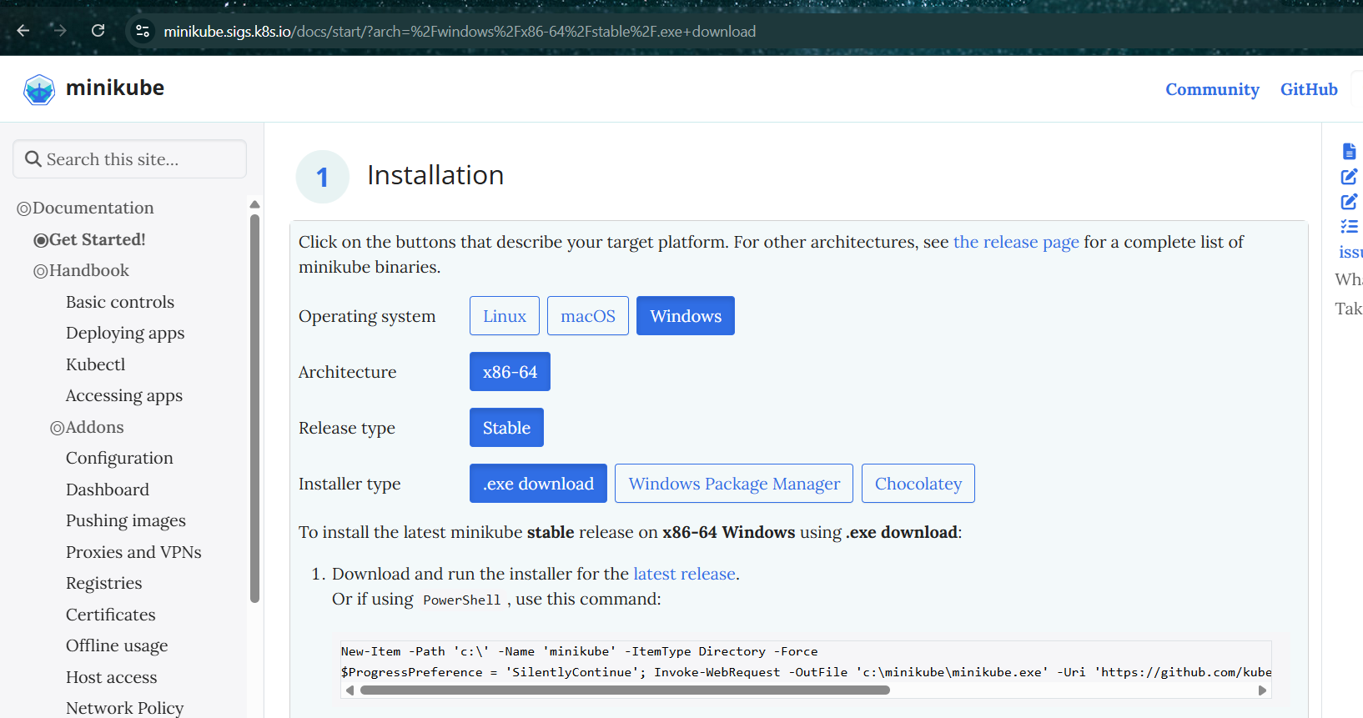
  - New-Item -Path 'c:\' -Name 'minikube' -ItemType Directory -Force
  - $ProgressPreference = 'SilentlyContinue'; Invoke-WebRequest -OutFile 'c:\minikube\minikube.exe' -Uri 'https://github.com/kubernetes/minikube/releases/latest/download/minikube-windows-amd64.exe' -UseBasicParsing
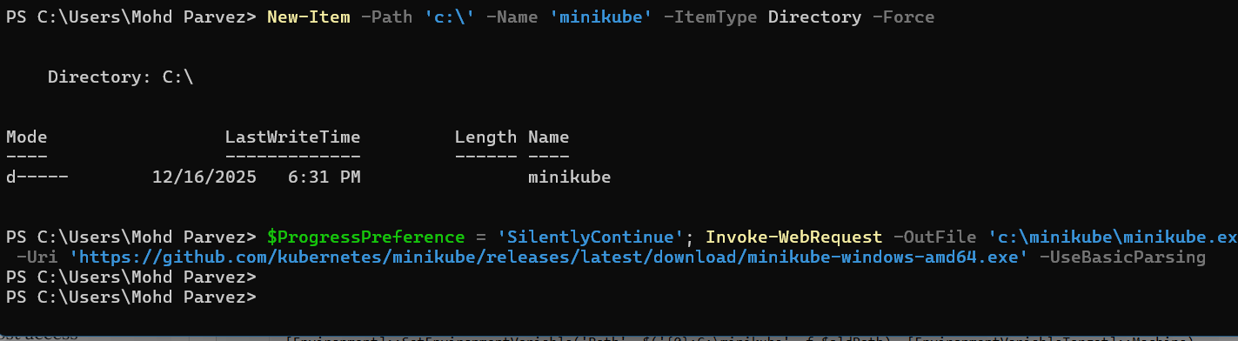
  - Step 4 : add environment variables in system
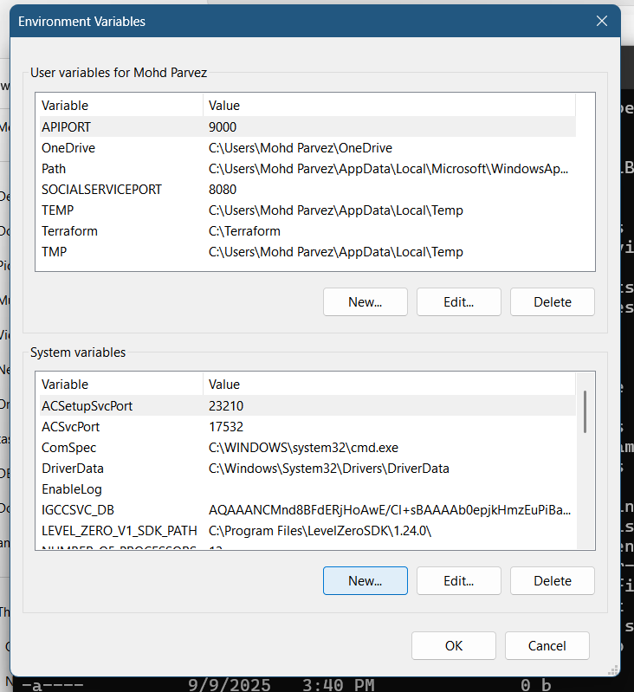
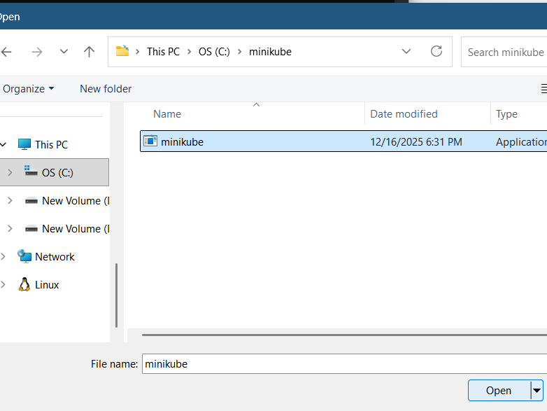
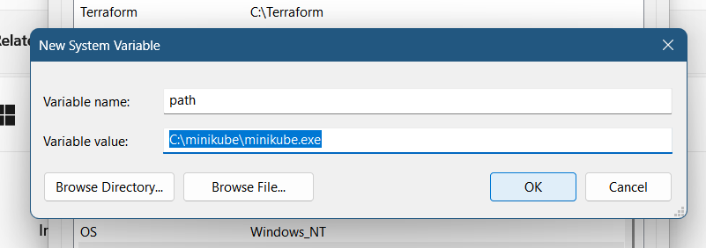
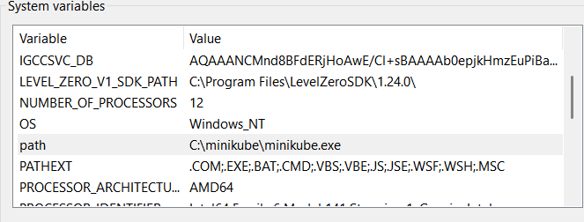
  - Minikube start : it is not working
  - 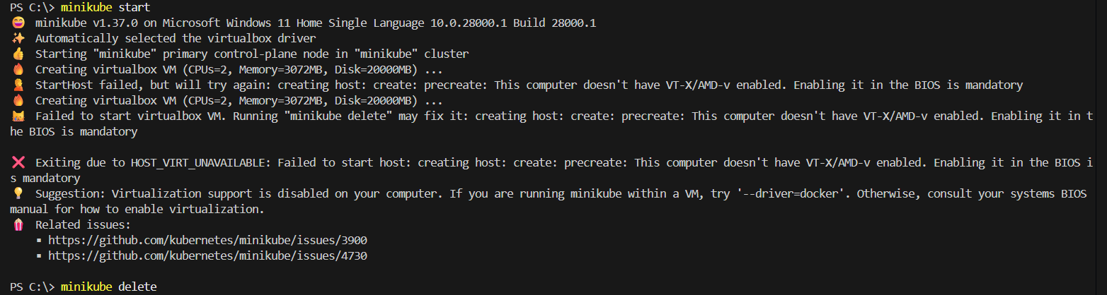
  - Minikube start does not work if you get the similar error
Start the minikube use : # Source - https://stackoverflow.com/a
  - # Posted by Paulo Souza
  - # Retrieved 2025-12-16, License - CC BY-SA 4.0
  - minikube start --driver=virtualbox --no-vtx-check
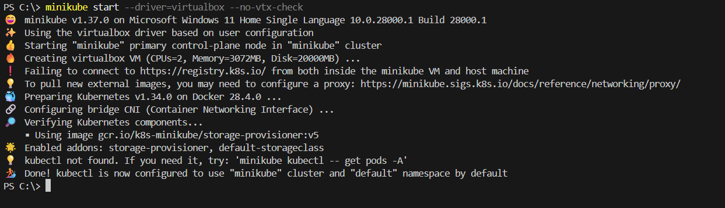
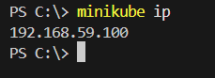

Setup k8s master and two worker nodes on ubuntu.
  - Step 1 : Master – t2.large (2 vCPU 8 GiB Memory) – launch one master node/ec2 and 2 worker nodes/ec2
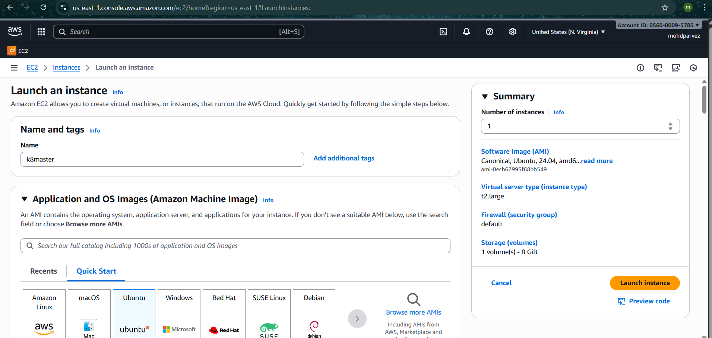
  - Switch to root user and turn off swap memory : swapoff -a
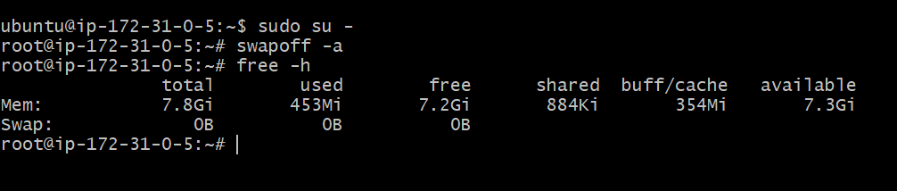
  - Change hostname to master:
#hostname master
#hostname
# vi /etc/hostname -- > master and save it
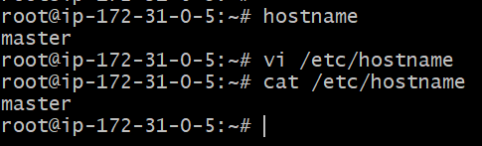
Now reconnect again
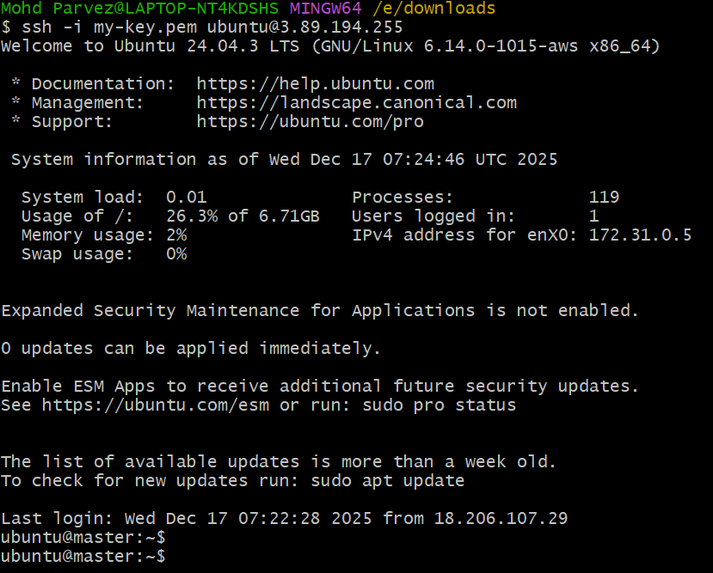

Now for the worker nodes do the same and name them worker1 and worker
  - Worker01
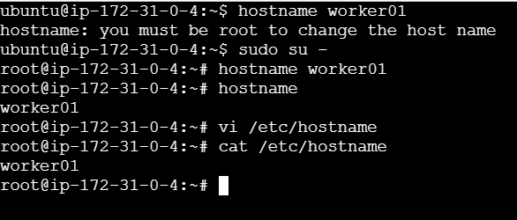
  - Reconnect again
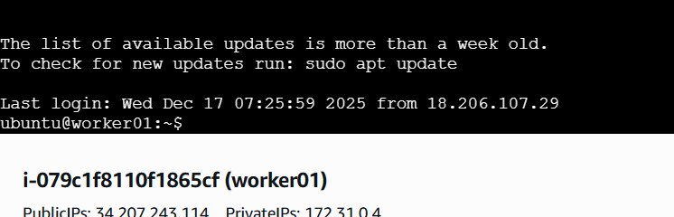
  - Now for the worker02
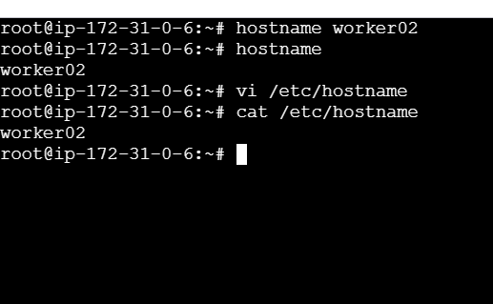
  - Reconnect again
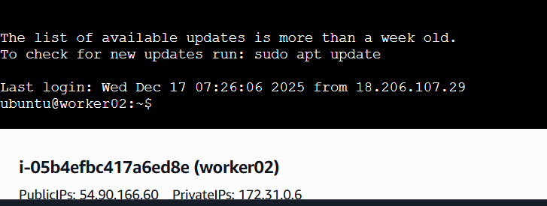

  - Setting up the IPV4 bridge on all nodes
cat <<EOF | sudo tee /etc/modules-load.d/k8s.conf
overlay
br_netfilter
EOF
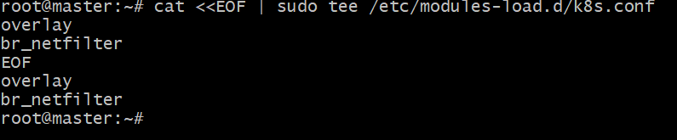
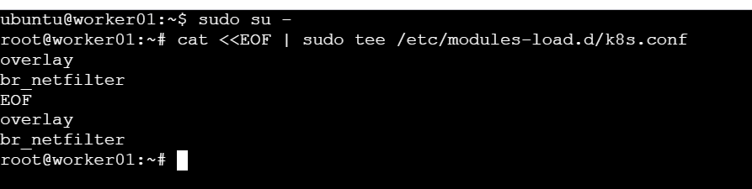
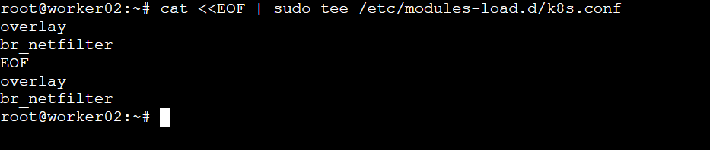

Run this command on all nodes
  - 1. sudo apt-get update
  - 2.sudo apt-get install -y apt-transport-https ca-certificates curl gpg
3. curl -fsSL https://pkgs.k8s.io/core:/stable:/v1.29/deb/Release.key | sudo gpg --dearmor -o /etc/apt/keyrings/kubernetes-apt-keyring.gpg
3. echo 'deb [signed-by=/etc/apt/keyrings/kubernetes-apt-keyring.gpg] https://pkgs.k8s.io/core:/stable:/v1.29/deb/ /' | sudo tee /etc/apt/sources.list.d/kubernetes.list
4. sudo apt-get update
5. sudo apt-get install -y kubelet kubeadm kubectl
sudo apt-mark hold kubelet kubeadm kubectl
Final output
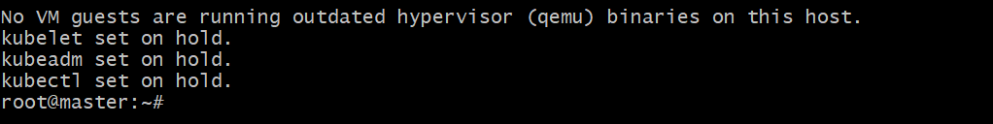
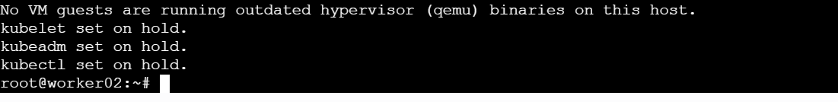
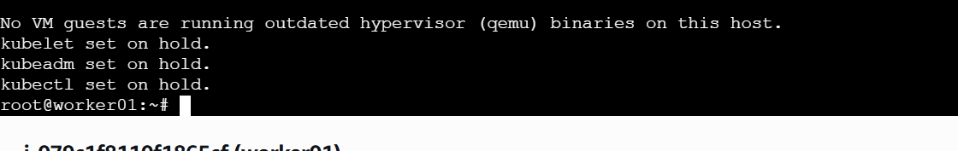
Kubectl –version
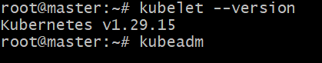
Kubectl version --client
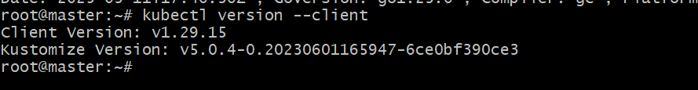
Kubeadm version
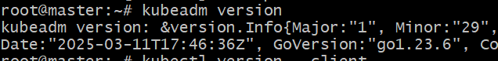

Run this command to install docker on all nodes
  - 1.sudo apt install docker.io
2. sudo mkdir /etc/containerd
3. sudo sh -c "containerd config default > /etc/containerd/config.toml"
4.sudo sed -i 's/ SystemdCgroup = false/ SystemdCgroup = true/' /etc/containerd/config.toml
5.sudo systemctl restart containerd.service
6.sudo systemctl restart kubelet.service
7.sudo systemctl enable kubelet.service
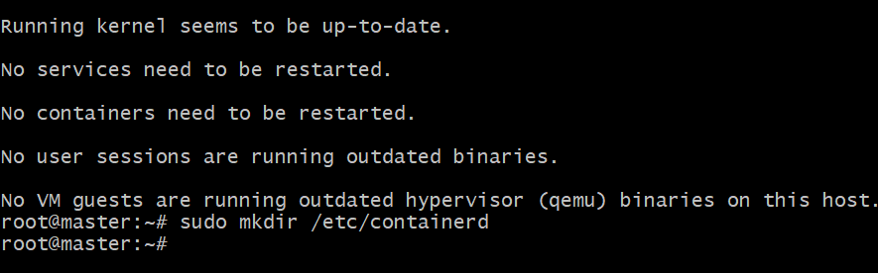
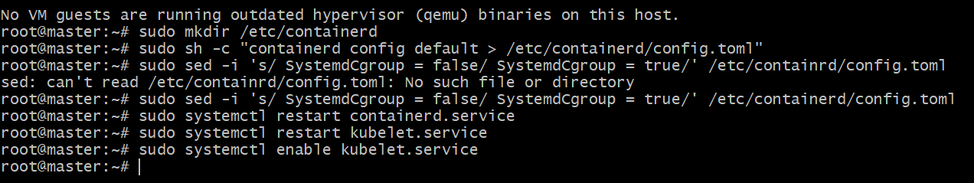
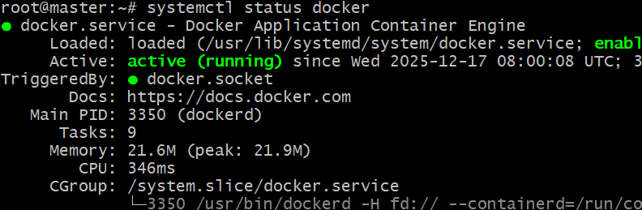
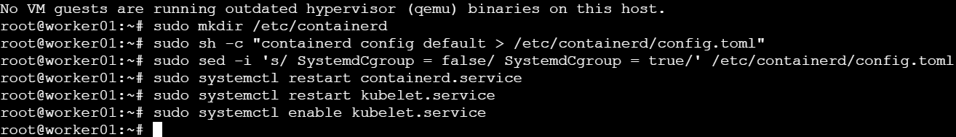
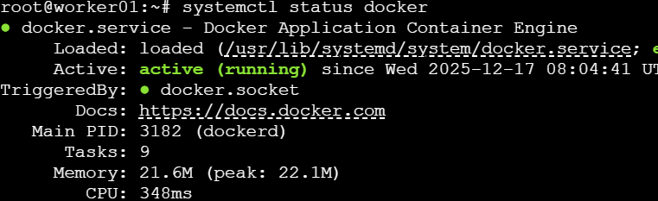

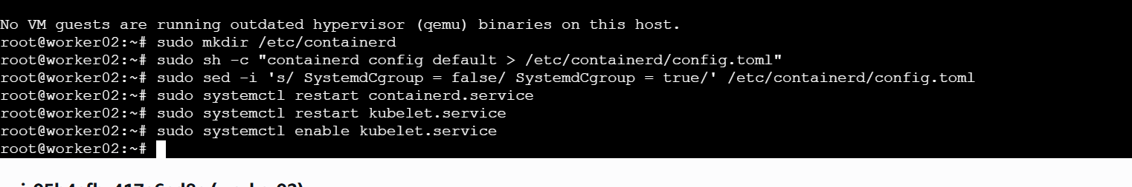
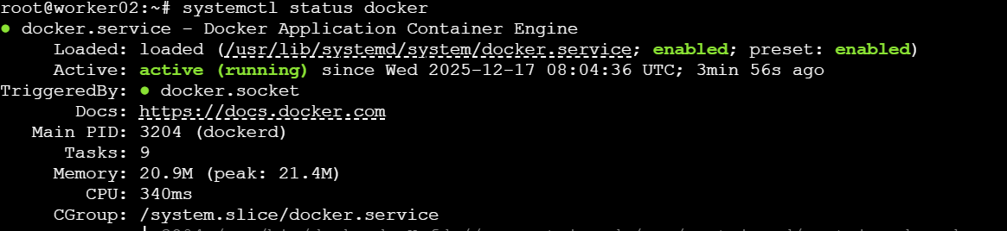
Initialising the kubernet on the master node
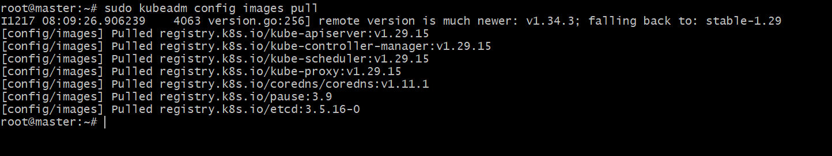
sudo kubeadm init --pod-network-cidr=10.10.0.0/16
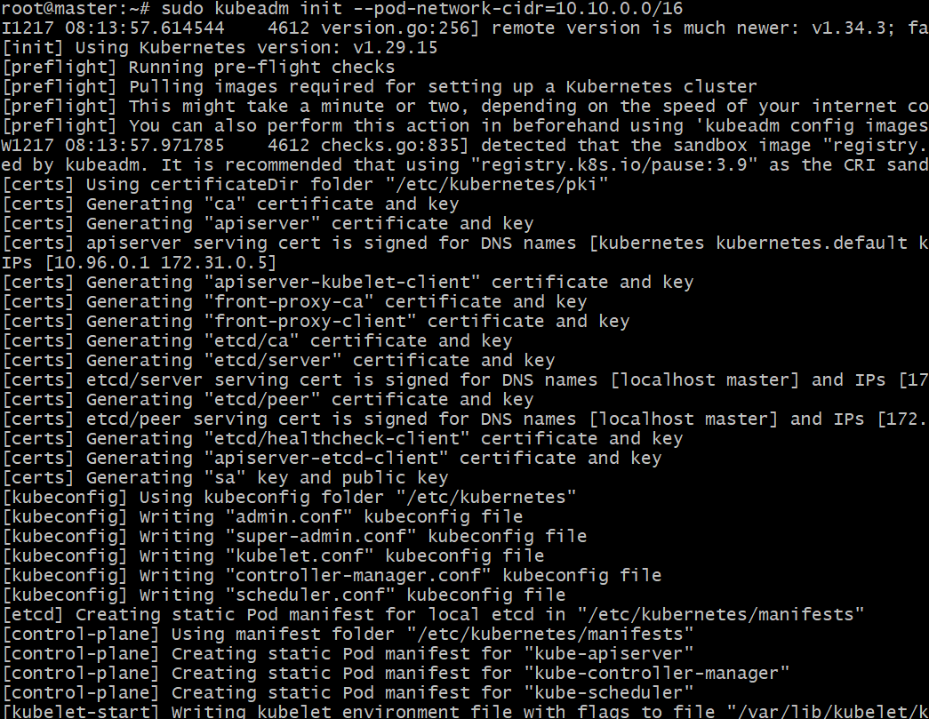
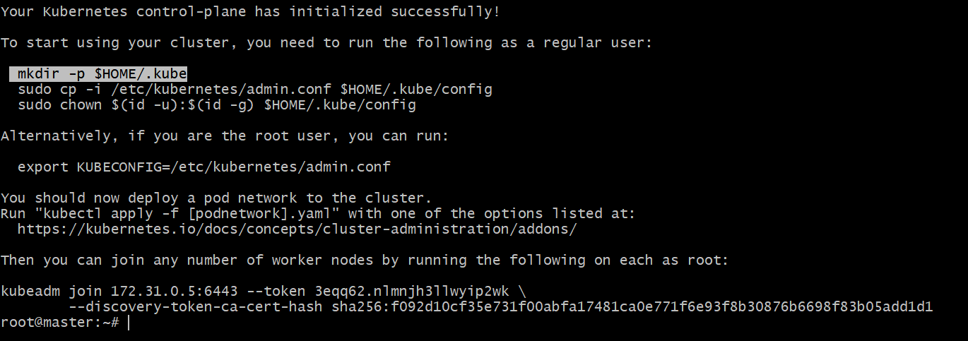
Run this on master
mkdir -p $HOME/.kube
sudo cp -i /etc/kubernetes/admin.conf $HOME/.kube/config
sudo chown $(id -u):$(id -g) $HOME/.kube/config
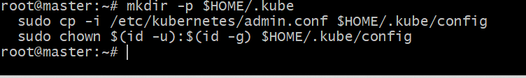
Run this on worker nodes
sudo kubeadm token create --print-join-command
kubeadm join 172.31.0.5:6443 --token 3eqq62.nlmnjh3llwyip2wk \
--discovery-token-ca-cert-hash sha256:f092d10cf35e731f00abfa17481ca0e771f6e93f8b30876b6698f83b05add1d1
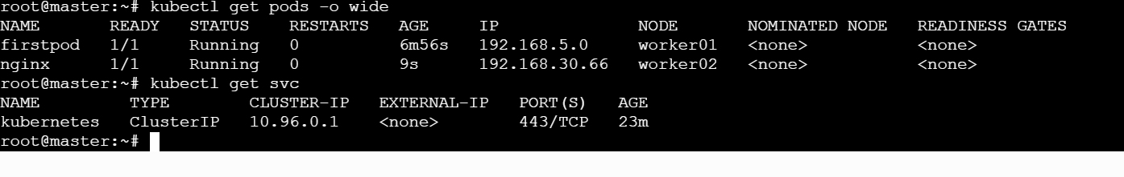
Worker 01
Worker02

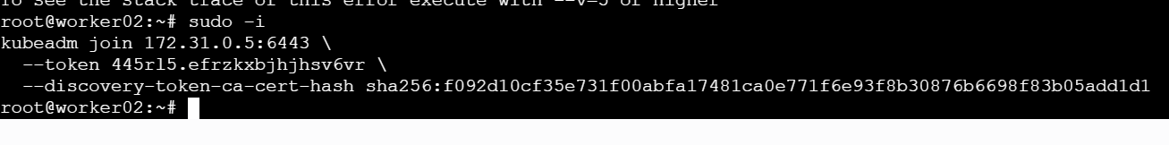
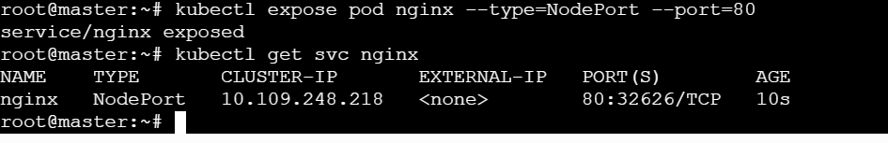

  - Install Flannel on master and check the status of nodes
kubectl apply -f https://github.com/flannel-io/flannel/releases/latest/download/kube-flannel.yml
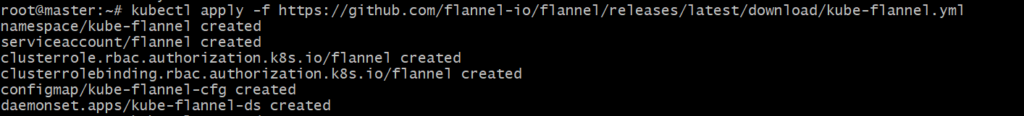
  - Check for nodes
Kubectl get nodes
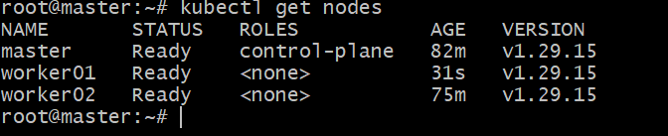

Run one nginx pod.
Kubectl run firstpod –image=nginx
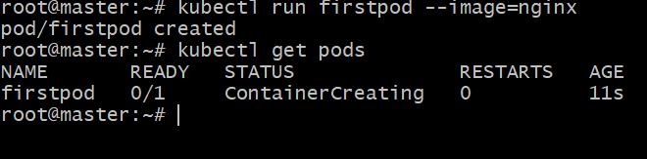
kubectl expose pod firstpod --port=80 --type=NodePort
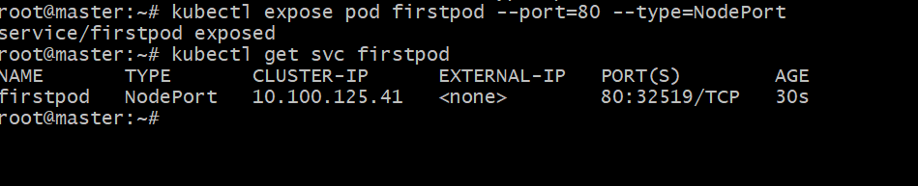

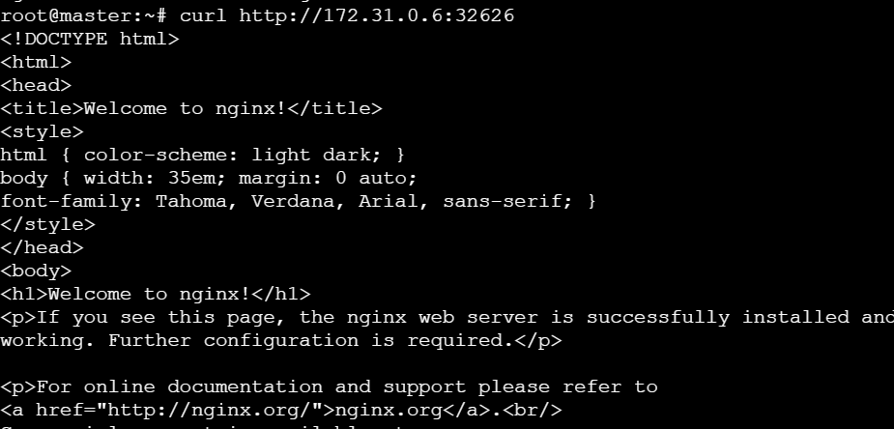

Mug up Master and slave components on k8s.
Master Components:
==================
1) Kube api server
2) etcd
3) Controller
4) Scheduler

worker node components:
=======================
1) Docker container runtime
2) Kubelet agent
3) Kubeproxy

Note: kubectl is a command line tool to execute k8s commands.

Api server: Acts as frontend of k8s,Authenticate user,authorization and api server is the only gateway to communciate with our k8s cluster.
Etcd: Cluster brain,which stores the information related to cluster,node in the form of key value pair.
Scheduler: Responsible to schedule pods on the node machine.
Controller manager: controller is the brain behind orchestration,if nodes,container,endpoint goes down then controller will work behind to bring them up.
Container runtime: any container service to start,stop container (Docker).
kubelet: Kubelet run on all the machines,kubelet make sure that the containers are running as expected on node machines.
KubeProxy: It maintains network rules on your nodes and enables network communication to your Pods.
Run this when you are not able to set the workers
sudo apt update
sudo apt install -y kubelet kubeadm kubectl
sudo apt-mark hold kubelet kubeadm kubectlsudo kubeadm init --pod-network-cidr=10.244.0.0/16only in master)
sudo kubeadm reset -f
sudo rm -rf /etc/kubernetes /var/lib/kubelet /var/lib/etcd /var/lib/cni /etc/cni
sudo iptables -F && sudo iptables -X
sudo iptables -t nat -F && sudo iptables -t nat -X
sudo iptables -t mangle -F && sudo iptables -t mangle -X
sudo ip vs del -all 2>/dev/null || true
sudo rm -rf /var/lib/containerd/io.containerd.metadata.v1.bolt
sudo crictl config runtime-endpoint unix:///run/containerd/containerd.sock
sudo apt update
sudo apt install -y cri-tools
sudo mkdir -p /etc/containerd
sudo containerd config default | sudo tee /etc/containerd/config.toml > /dev/null
sudo sed -i 's|sandbox_image = ".*"|sandbox_image = "registry.k8s.io/pause:3.10.1"|g' /etc/containerd/config.toml
sudo sed -i 's|SystemdCgroup = false|SystemdCgroup = true|g' /etc/containerd/config.toml
sudo ctr images pull registry.k8s.io/pause:3.10.1
sudo systemctl restart containerd
sudo systemctl enable containerd
sudo systemctl restart kubelet
sudo crictl info | head -n 20
sudo journalctl -u kubelet -n 100 --no-pager
kubeadm token create --print-join-command (in master node)

